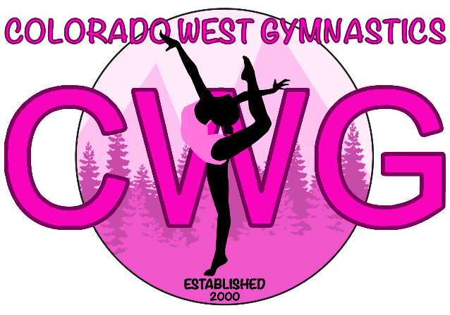
SUMMER PASS NOW AVAILABLE
45 Minute Classes - $85 60 Minute Classes $90

- Use during the months of June and July
- Pay for 6 classes instead of 7

- Makes planning summer vacation easy
- Saves your spot for the fall

**Weeks Available for Use – June1, June 7, June 14, June 21, July 12, July 19, and July 26
Colorado West Gymnastics will be closed June 28th through July 10th

