SUMMER GYMNASTICS CAMP  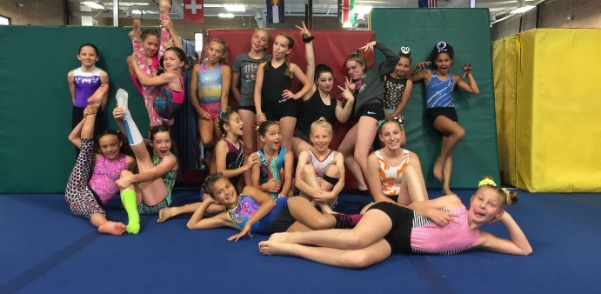  Camp $200 – Payment Due May 3rd  4Hr/Day – Monday through Thursday  Skill Development & Fundamental Drills  Build Friendships and Team Bonding  Themed Day for Added FUN  Bronze and Hotshot Group – June 7 - 10  Silver Group – June 14 - 17  Gold, Platinum, and Diamond – June 21 - 24 | SUMMER GYMNASTICS CAMP  Camp $200 – Payment Due May 3rd  4Hr/Day – Monday through Thursday  Skill Development & Fundamental Drills  Build Friendships and Team Bonding  Themed Day for Added FUN  Bronze and Hotshot Group – June 7 - 10  Silver Group – June 14 - 17  Gold, Platinum, and Diamond – June 21 - 24

